ST. XAVIER’S COLLEGE

**Maitighar, Kathmandu**

**(Affiliated to Tribhuvan University)**



**Database Management System**

**Submitted By**

Pratik Gautam

013BSCIT029

B.Sc. CSIT Year II/IV Semester

**Submitted To**

Er. Sanjay Kumar Yadav

Lecturer

Department of Computer Science

St. Xavier’s College

Maitighar, Kathmandu

**Submitted On**

September 2015

1) find eno, ename and salary form employee whose salary is greater than 4000.

Sql statement

select eno, ename, salary from employee where salary>4000

output

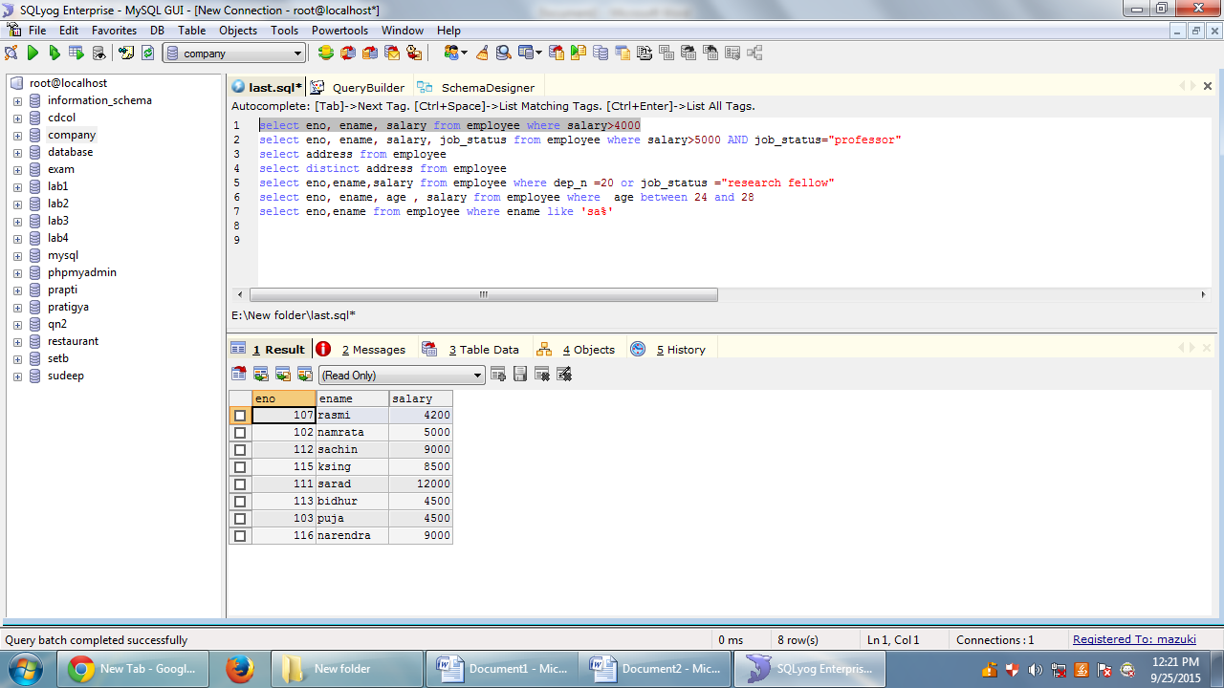

2) find the eno ename salary of the employee whose salary is greater than 5000 job status is professor.

Sql statement

select eno, ename, salary, job_status from employee where salary>5000 AND job_status="professor"

output

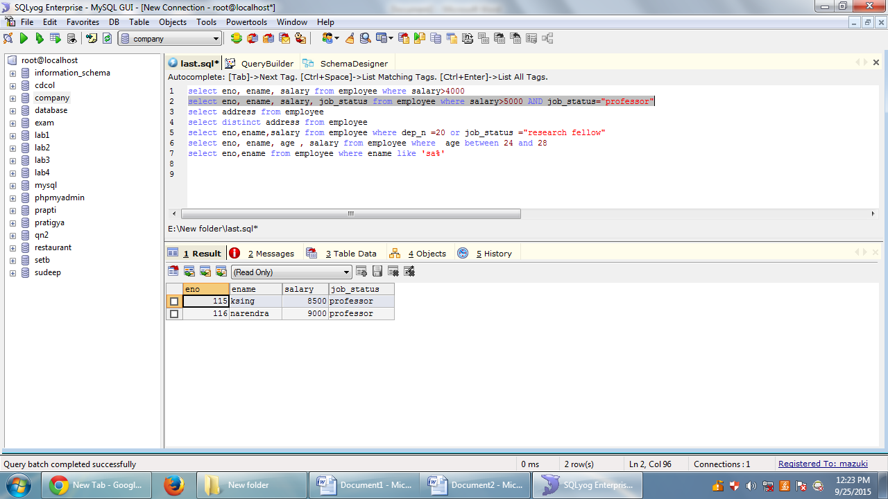

3)

Sql statement

select address from employee

output

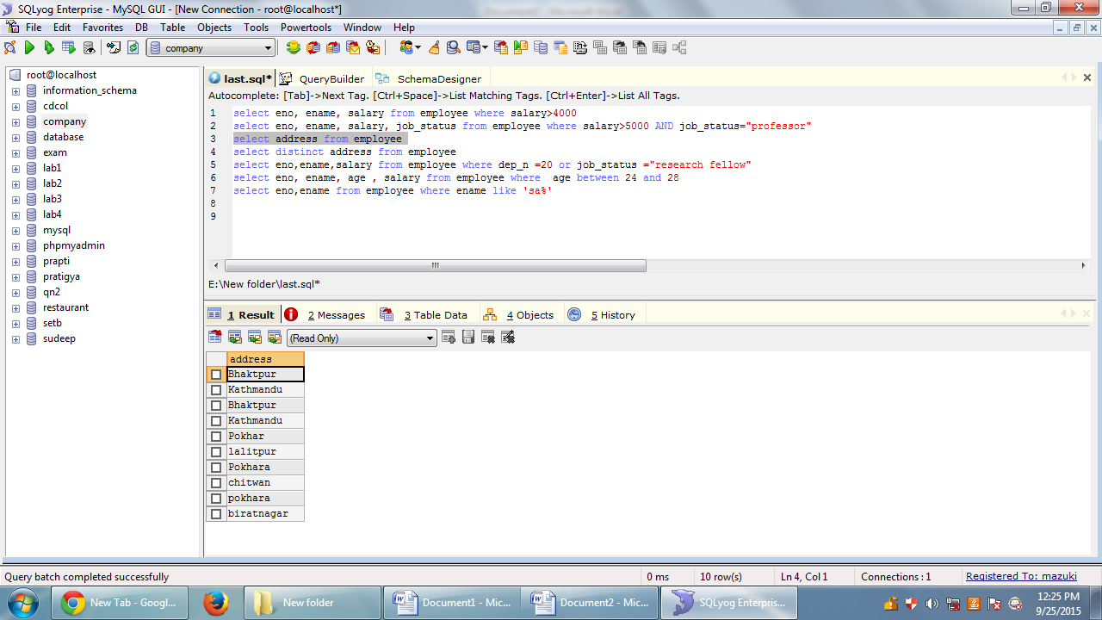

4)

Sql statement

select distinct address from employee

output

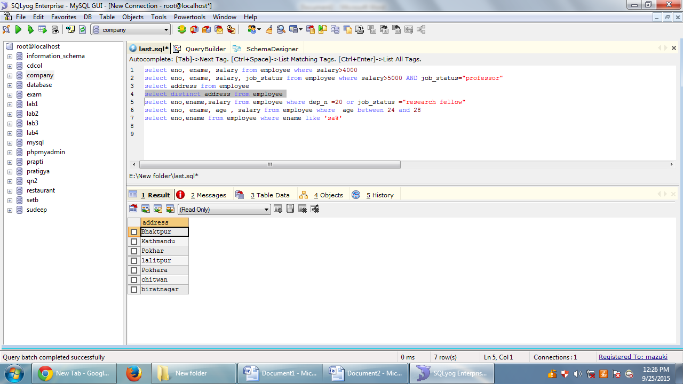

5) Find the eno,ename,salary of the employee whose department 20 or job status research fellow.

Sql statement

select eno,ename,salary from employee where dep_n =20 or job_status ="research fellow"

output

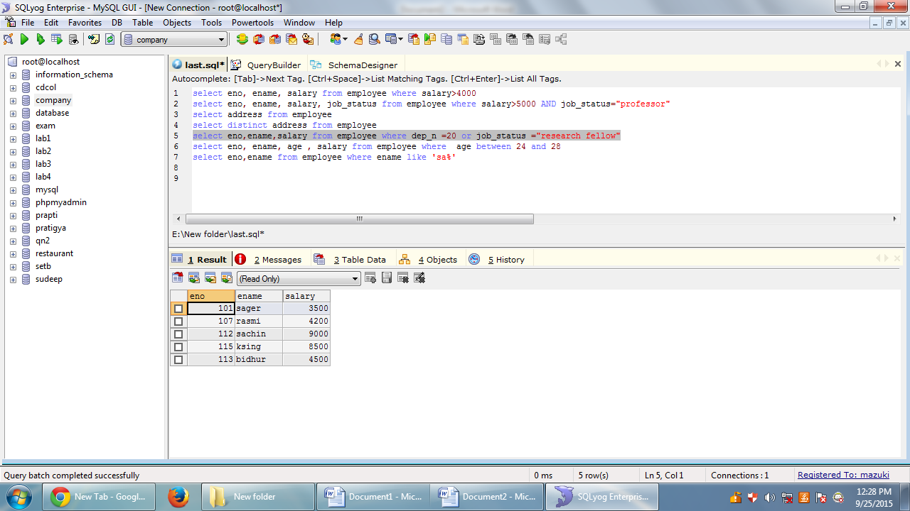

6) Find the eno, ename, age , salary form the employee where the age is between 24 and 28

Sql statement

select eno, ename, age , salary from employee where age between 24 and 28

output

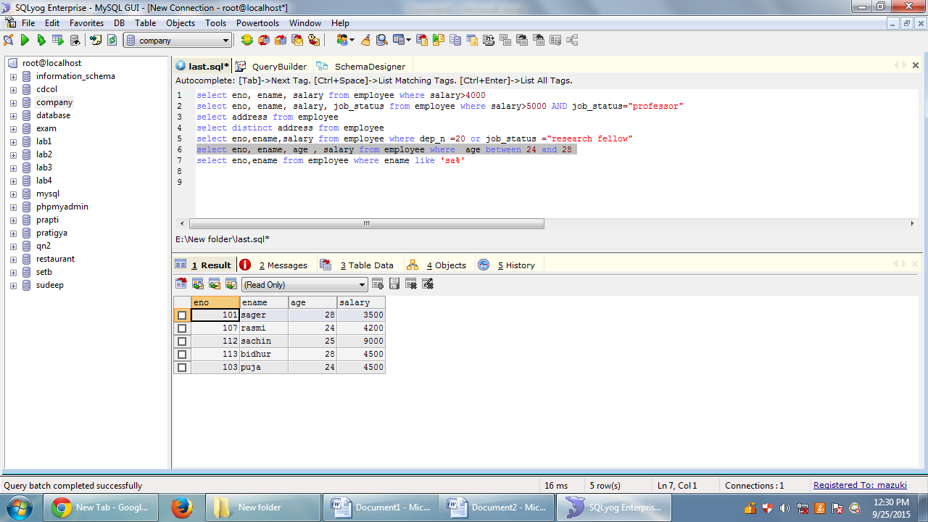

7)

Sql statement

select eno,ename from employee where ename like 'sa%'

output

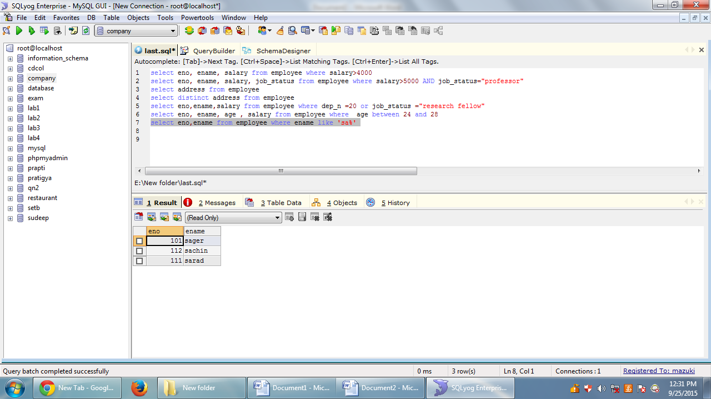

8) list all employee name with their project name

Sql statement

select eno,ename from employee where ename like 'sa%'

output

9) list name of all employee and salary who are working in project mars or venus.

Sql statement

select eno,ename from employee where ename like 'sa%'

output

10) list name of all employee and their salary who are working in project earth and venus.

Sql statement

select eno,ename from employee where ename like 'sa%'

output

11) list name, address of all employee who works in department which is located in pokhara.

Sql statement

select eno,ename from employee where ename like 'sa%'

output